**HO CHI MINH UNIVERSITY OF TECHNOLOGY AND EDUCATION**

**FACULTY FOR HIGH QUALITY TRAINING**

**--------****--------**



**SOFTWARE ENGINEERING PROJECT**

**Build an agricultural product trading system**

**Students:**

|  |  |
| --- | --- |
| **Pham Viet Anh** | * **19110151** |
| **Tran Dang Khoa** | * **19110145** |
| **Nguyen Le Minh Nhut** | * **19110100** |

**Instructor:**

**Dr. Nguyen Thien Bao**

--- Ho Chi Minh, December 2022 ---

**SOCIALIST REPUBLIC OF VIETNAM**

**Independence - Freedom – Happiness**

**\*\*\*\*\*\*\***

**GRADUATION THESIS TASK**

**Student Name**: Pham Viet Anh **Student ID:** 19110151

**Student Name**: Tran Dang Khoa **Student ID:** 19110145

**Student Name**: Nguyen Le Minh Nhut **Student ID:** 19110100

1. **Major:** Software Engineering
2. **Project title:** Build a system to trade agricultural products.
3. **Advisor:** PhD. Nguyen Thien Bao
4. Original data and documents:
5. Content implementation of the topic:

* Learn about Angular, React Native, Spring Boot, MySql, Material, Tensorlow.
* Building a system of buying and selling agricultural products between merchants and farmers

**INSTRUCTOR**

Nguyen Thien Bao

**SOCIALIST REPUBLIC OF VIETNAM**

**Independence - Freedom – Happiness**

**\*\*\*\*\*\*\***

**ADVISOR’S EVALUATION SHEET**

**Student Name**: Pham Viet Anh **Student ID:** 19110151

**Student Name**: Tran Dang Khoa **Student ID:** 19110145

**Student Name**: Nguyen Le Minh Nhut **Student ID:** 19110100

**Major:** Software Engineering

**Project title:** Build a system to trade agricultural products.

**Advisor:** Dr. Nguyen Thien Bao

**EVALUATION**

1. Content of the project:
2. Theory: Angular, React Native, Spring Boot, MySQL, Tensorflow
3. Experiments:

- Research renowned websites about agricultural products to decide what features and functions to include in our projects. To determine the project's requirements, identify key points and significant business - build a system to trade agricultural products, meaning a system of buying and selling agricultural products between merchants and farmers.

- Discover Angular, SpringBoot, and React Native. Effectively using additional libraries, apply it to the project.

- Build Back-end (with SpringBoot) and front-end (React Native and Angular). Connect them together libraries to build up the construction of an online can interact between a website and a mobile device with both basic and advanced features.

- Use Tensorflow to detect fruit with high

1. Link:

- Git: <https://github.com/nohoopes/project-on-software-engineering>

- Drive (mobile): <https://drive.google.com/drive/folders/1g9k10TZ1K4BL3qPsCUsukeXsWVJCCahP>

- Deploy (web): <https://detect-style-interior.vercel.app/>

1. Strengths:

- Project:

+ Specifically contains all features required for the significant business.

+ Friendly user interface, simple operation, and reliable connections.

+ Convenient trading on a variety of platforms, with an emphasis on a unique group of clients (farmers) to give users fresh experiences.

- Group:

+ Teamwork and effective communication.

+ Assign tasks to each team member evenly.

+ Each person does an aspect, so there is less code conflict.

1. Weaknesses:

- Project:

+ A few operations are lacking.

+ Responsive web design isn't actually optimized.

+ Free hosting servers require a new hosting session every 20 days.

+ CORS errors in the Website.

- Group:

+ Having problems handling the logic of complex functions.

+ Difficult to help each other as well as intergrate APIs because each person is in charge of a technology.

+ Since all the members are working, there is not much time to work on the project.

1. Approval for oral defense? (Approved or denied)

...........................................................................................................................................

1. Overall evaluation: (Excellent, Good, Fair, Poor)

...........................................................................................................................................

1. Mark: ………. (in words: .........................................................................................)

Ho Chi Minh City, December 2022

**ADVISOR**

*(Sign with full name)*

**SOCIALIST REPUBLIC OF VIETNAM**

**Independence - Freedom – Happiness**

**\*\*\*\*\*\*\***

**PRE-DEFENSE EVALUATION SHEET**

**Student Name**: Pham Viet Anh **Student ID:** 19110151

**Student Name**: Tran Dang Khoa **Student ID:** 19110145

**Student Name**: Nguyen Le Minh Nhut **Student ID:** 19110100

**Major:** Software Engineering

**Project title:** Build a system to trade agricultural products.

**Name of Reviewer:** Assoc. Prof. Hoang Van Dung

**EVALUATION**

1. Content of the project:

......................................................................................................................................................................................................................................................................................

1. Strengths:

......................................................................................................................................................................................................................................................................................

1. Weaknesses:

...........................................................................................................................................

1. Approval for oral defense? (Approved or denied)

...........................................................................................................................................

1. Overall evaluation: (Excellent, Good, Fair, Poor)

...........................................................................................................................................**6.** Mark: ………. (in words: .........................................................................................)

Ho Chi Minh City, January 2023

**REVIEWER**

*(Sign with full name)*

**ACKNOWLEDGEMENT**

Mr. Nguyen Thien Bao, the instructor of our course, deserves special thanks from our team. Throughout this course, you have constantly assisted us with our difficulties in the study process as well as provided us with excellent feedback and recommendations to help us grow as developers in the future. As a result, you have become our inspiration for this final project, and we would like to express our gratitude for the opportunity to learn from you in this course.

Everyone on our team has various talents, and we have discovered our shortcomings in each other over this final assignment, but we've all managed to face this challenge as a team. As a result, everyone on our team is really grateful for the opportunity to collaborate.

Thank you to the teachers in the Faculty for High Quality Training for always being enthusiastic, dedicated, and dedicated to answering our questions. Besides, we would like to thank our classmates and seniors who did not hesitate to share useful information and experiences to help us improve our thesis.

This final project is the result of our tireless efforts throughout the semester. Because we are still novices, we are aware that our design has numerous shortcomings. We welcome any feedback as well as suggestions for improving our project. We appreciate it. Sincerely!

Ho Chi Minh city, December …., 2022

Group

Pham Viet Anh

Tran Dang Khoa

Nguyen Le Minh Nhut

TABLE OF CONTENTS

CHAPTER 1: INTRODUCTION 2

1.1. Project overview 2

1.2. The purpose of project 2

1.3. Object and scope of the study 3

1.4. Expected results 3

CHAPTER 2. THEORY FUNDAMENTALS 4

2.1. Angular 4

2.2. React Native 5

2.3. Spring Boot 6

2.4. MySQL 7

2.5. Postman 7

2.6. Tensorflow 8

CHAPTER 3. state of the art AND Rsytem EQUIREMENT MODELING 10

3.1. State of the art 10

3.2. System requirements 10

3.3. Requirement analysis 11

3.3.1. Functional requirements 11

3.3.2. Non-functional requirements 14

3.4. Bussiness model 15

CHAPTER 4. SYSTEM DESIGN 16

4.1. List of actors and usecases 16

4.1.1. Identify actors and use cases in use case diagrams 16

4.1.2. Detailed description 16

4.1.3. Usecase summary 17

4.2. Usecase diagram 18

4.3. Usecase specifications 21

4.4. Database design 25

4.4.1. Database table 25

4.4.2. Relational diagram 30

4.5. User interface 31

4.5.1. Mobile for merchant 31

4.5.2. Website for farmer 46

CHAPTER 5: SYSTEM ARCHITECTURE AND TECHNOLOGY 52

5.1. Overall architecture of the system 52

5.2. Tensorflow 53

CHAPTER 6. SOFTWARE TESTING 55

6.1. Introduction 55

6.1.1. Purpose 55

6.1.2. Project overview 55

6.1.3. Audience 56

6.2. Test strategy 56

6.2.1. Test objectives 56

6.2.2. Test assumptions 56

6.2.3. Test principles 57

6.2.4. Data approach 57

6.2.5. Scope and levels of testing 58

6.2.6. Test effort estimate 58

6.3. Execution strategy 58

6.3.1. Entry and exit criteria 58

6.3.2. Test cycles 59

6.3.3. Validation and defect management 59

6.3.4. Test metrics 60

6.3.5. Defect tracking and reporting 60

6.4. Test management process 60

6.4.1. Testing management tool 60

6.4.2. Testing process 60

6.4.3. Test risks and mitigation factors 61

6.4.4. Communications plan and team roster 62

6.5. Test environment 63

CHAPTER 7. CONCLUSION 65

7.1. Achieved result 65

7.2. Advantages 65

7.3. Disadvantages 66

7.4. Future developments 66

# CHAPTER 1: INTRODUCTION

## 1.1. Project overview

Vietnam is an agricultural nation, and as of 2017, agricultural products continued to account for a sizable share of the country's exports.

The remaining agricultural products were previously mostly consumed at wholesale marketplaces, with purchasing agents in large centers before coming to the market, in addition to being supplied to supermarkets and import-export businesses. consumers.

The growth of the digital economy has altered how society currently views business. As can be seen, any good or service, including agricultural goods, can be advertised and made "for sale" online. Additionally, consumers want to know whether the agricultural products they buy are of good quality and safe for their health.

Therefore, managers need a more effective communication channel and website/mobile design is the chosen option. This is in addition to enhancing the quality of agricultural products, communicating the brand, and improving the packaging to uphold the quality reputation.

## 1.2. The purpose of project

The portal allows farmers to first post agricultural items that are only available for a limited time, along with personal and contact information. The merchandiser's mobile application will then show the products, allowing them to select the ones that are best suited to their requirements. The retailer will provide a pricing after determining the appropriate goods and quantity, and will then send the gardener a request along with contact details like their phone number, address, and shipping address. If the farmer accepts, he will confirm and the merchant will receive a successful notification. In contrast, if the farmer rejects the request, it will be declined and a notice of the rejection will be given to the merchant. The farmer may also recommend a different price, and the two parties may speak over the phone to discuss it. Once both parties have consented, the farmer can use the exchange button to display the form, fill it out with the new price, and submit it back to the merchant for confirmation before resuming the transaction. The merchant will receive updated information to review and validate. The deal is finished if everything goes according to plan and the farmer confirms; if not, it is canceled.

## 1.3. Object and scope of the study

Two focus groups of participants, including those with and without prior knowledge of technology, were used in the investigation.

Which covers the Angular, React Native, MySQL database, Spring Boot, as well as a little application about tensorflow among the group of technical knowledge areas. Many useful Javascript libraries are adding to the list of research topics on technology expertise.

The research's main objectives are outlined, and the researcher has a general understanding of its subject matter and is able to apply each knowledge point to the finished product without heavily emphasizing theories. non-applicable.

## 1.4. Expected results

Topic “BUILD A SYSTEM TO TRADE AGRICULTURAL PRODUCTS” serves following purposes:

- Building a website for farmers can management their products as well as orders.

- Building a mobile application for merchants can find and trade agricultural products with farmers.

- Building a system of buying and selling agricultural products between merchants and farmers with a user-friendly interface, easy to use.

# CHAPTER 2. THEORY FUNDAMENTALS

## 2.1. Angular

***What is Angular?***

Angular is a platform and framework for building single-page client applications using HTML and TypeScript. Angular is written in TypeScript. It implements core and optional functionality as a set of TypeScript libraries that you import into your applications.

The architecture of an Angular application relies on certain fundamental concepts. The basic building blocks of the Angular framework are Angular components that are organized into NgModules. NgModules collect related code into functional sets; an Angular application is defined by a set of NgModules. An application always has at least a root module that enables bootstrapping, and typically has many more feature modules.

Components define views, which are sets of screen elements that Angular can choose among and modify according to your program logic and data

Components use services, which provide specific functionality not directly related to views. Service providers can be injected into components as dependencies, making your code modular, reusable, and efficient.

Modules, components and services are classes that use decorators. These decorators mark their type and provide metadata that tells Angular how to use them.

The metadata for a component class associates it with a template that defines a view. A template combines ordinary HTML with Angular directives and binding markup that allow Angular to modify the HTML before rendering it for display.

The metadata for a service class provides the information Angular needs to make it available to components through dependency injection (DI).

An application's components typically define many views, arranged hierarchically. Angular provides the Router service to help you define navigation paths among views. The router provides sophisticated in-browser navigational capabilities.

***Why we use it?***

Angular is one of the most popular frameworks for creating web and mobile applications. If you’re planning to build a digital product, Angular may be the perfect tool to create a high-quality app with less code, less time spent on debugging, and high scalability potential.

Here are some of the benefits of using Angular to build your next digital product:

- Shorter Development Time

- Safety

- Easy Testing

- Cross-Platform Development

- Cost-Effectiveness

## 2.2. React Native

***What is React Native?***

React Native is a JavaScript framework for writing real, natively rendering mobile applications for iOS and Android. It’s based on React, Facebook’s JavaScript library for building user interfaces, but instead of targeting the browser, it targets mobile platforms. In other words: web developers can now write mobile applications that look and feel truly “native,” all from the comfort of a JavaScript library that we already know and love. Plus, because most of the code you write can be shared between platforms, React Native makes it easy to simultaneously develop for both Android and iOS.

Similar to React for the Web, React Native applications are written using a mixture of JavaScript and XML-esque markup, known as JSX. Then, under the hood, the React Native “bridge” invokes the native rendering APIs in Objective-C (for iOS) or Java (for Android). Thus, your application will render using real mobile UI components, not webviews, and will look and feel like any other mobile application. React Native also exposes JavaScript interfaces for platform APIs, so your React Native apps can access platform features like the phone camera, or the user’s location.

React Native currently supports both iOS and Android, and has the potential to expand to future platforms as well. In this book, we’ll cover both iOS and Android. The vast majority of the code we write will be cross-platform. And yes: you can really use React Native to build production-ready mobile applications! Some anecdota: Facebook, Palantir, and TaskRabbit are already using it in production for user-facing applications.

***Why we use it?***

For a long time, React Native was considered to be commercially unviable. It wasn’t developed or supported enough to produce “native-like” apps.

But the times have changed. React Native is gaining popularity, gaining community support, and gaining more market share. It’s getting easier and easier to write brilliant apps using React Native—and the world is taking notice.

Tried and trusted

Facebook built React Native first and foremost to create a fantastic mobile app for their own social portal. More likely than not, you’ve used it on your phone by way of the Facebook mobile app. Does it feel like a native app? Sure it does.

But since React Native has gone open-source, more companies have decided to bet on it and create their mobile apps this way.

## 2.3. Spring Boot

***What is Spring Boot?***

Spring Boot provides a good platform for Java developers to develop a stand-alone and production-grade spring application that you can just run. You can get started with minimum configurations without the need for an entire Spring configuration setup.

***Why we use it?***

You can choose Spring Boot because of the features and benefits it offers as given here:

- It provides a flexible way to configure Java Beans, XML configurations, and Database Transactions.

- It provides a powerful batch processing and manages REST endpoints.

- In Spring Boot, everything is auto configured; no manual configurations are needed.

- It offers annotation-based spring application

- Eases dependency management

- It includes Embedded Servlet Container

## 2.4. MySQL

***What is MySQL?***

MySQL is a relational database management system based on SQL – Structured Query Language. The application is used for a wide range of purposes, including data warehousing, e-commerce, and logging applications.

The most common use for mySQL however, is for the purpose of a web database. It can be used to store anything from a single record of information to an entire inventory of available products for an online store.

In association with a scripting language such as PHP or Perl (both offered on our hosting accounts) it is possible to create websites which will interact in real-time with a mySQL database to rapidly display categorised and searchable information to a website user.

***Why we use it?***

We use MysqlDB because:

- Scalability and Flexibility

- High Performance

- High Availability

- Robust Transactional Support

- Web and Data Warehouse Strengths

- Strong Data Protection

- Comprehensive Application Development

- Management Ease

- Open Source Freedom and 24 x 7 Support

- Lowest Total Cost of Ownership

## 2.5. Postman

***What is Postman?***

Postman is an API client that makes it easy for developers to create, share, test and document APIs. With this open-source solution, users can create and save simple and complex HTTP/s requests, as well as read their responses.

***Why we use it?***

There are many benefits to using open-source Postman for API testing, including:

- Accessibility from the cloud. When you are signed into your account, you are able to access your files. You can execute Postman API tests anytime, anywhere.

- Collaboration. Postman's import and export capabilities make it easier to share files with other team members, enabling closer collaboration.

- Test Creation. You can add test checkpoints such as verifying successful HTTP response statuses to your Postman API calls. This capability can help teams achieve more comprehensive test coverage.

- Automated API Testing. With features such as Collection Runner, you can automate Postman API tests, saving time and resources.

- Simpler debugging. The Postman console makes it easier to debug API tests by helping teams check the retrieved data.

- Collections. Postman's Collections features enables teams to group together multiple related APIs, which helps with organizing test suites.

## 2.6. Tensorflow

***What is Tensorflow?***

TensorFlow is an end-to-end open source platform for machine learning. It has a comprehensive, flexible ecosystem of tools, libraries, and community resources that lets researchers push the state-of-the-art in ML and developers easily build and deploy ML-powered applications.

TensorFlow was originally developed by researchers and engineers working on the Google Brain team within Google's Machine Intelligence Research organization to conduct machine learning and deep neural networks research. The system is general enough to be applicable in a wide variety of other domains, as well.

TensorFlow provides stable Python and C++ APIs, as well as non-guaranteed backward compatible API for other languages.

***Why we use it?***

- Easy model building:

TensorFlow offers multiple levels of abstraction so you can choose the right one for your needs. Build and train models by using the high-level Keras API, which makes getting started with TensorFlow and machine learning easy.

If you need more flexibility, eager execution allows for immediate iteration and intuitive debugging. For large ML training tasks, use the Distribution Strategy API for distributed training on different hardware configurations without changing the model definition.

- Robust ML production anywhere:

TensorFlow has always provided a direct path to production. Whether it's on servers, edge devices, or the web, TensorFlow lets you train and deploy your model easily, no matter what language or platform you use.

Use TFX if you need a full production ML pipeline. For running inference on mobile and edge devices, use TensorFlow Lite. Train and deploy models in JavaScript environments using TensorFlow.js.

- Powerful experimentation for research:

Build and train state-of-the-art models without sacrificing speed or performance. TensorFlow gives you the flexibility and control with features like the Keras Functional API and Model Subclassing API for creation of complex topologies. For easy prototyping and fast debugging, use eager execution.

TensorFlow also supports an ecosystem of powerful add-on libraries and models to experiment with, including Ragged Tensors, TensorFlow Probability, Tensor2Tensor and BERT.

# CHAPTER 3. state of the art AND Rsytem EQUIREMENT MODELING

## 3.1. State of the art

Store information about farmers, agricultural products, merchants, registration information, … Merchants who want to order agricultural products such as mango, watermelon, … must log in to the system by mobile app. Farmers will be able to add and delete their agricultural products on management website. Process for agricultural products ordering:

- Merchants will log into the system.

- Merchants looking for agricultural that match their needs.

- After finding the agricultural products, they will proceed to order on the system.

- The system will send a message to farmer in order to accept or not.

## 3.2. System requirements

**\* Archive:**

The system stores information about:

- Farmer information

- Merchant information

- Agricultural information…

- Optional information: offers, deals, ...

**\* Lookup:**

- Merchants:

+Look up agricultural products infomation.

+ Look up farmers infomation.

- Farmers:

+ Look up order history.

**\* Calculate:**

-Farmers:

+Number of their agricultural products.

+ Number of merchants ordered.

- Merchants:

+ Number of orders.

+ Total order amount.

## 3.3. Requirement analysis

### 3.3.1. Functional requirements

**\* Business functional requirements:**

***Department: Merchant***

|  |  |  |  |  |  |
| --- | --- | --- | --- | --- | --- |
| No. | Work | Work type | Regulations/Related Formulas | Related forms | Note |
| 1 | View the list of agricultural products | Search |  |  |  |
| 2 | Validate farmer’s deal | Store |  |  | Accept/Deline the final price of the order |
| 3 | Agricultural products search | Search | Search by agricultural products name |  |  |
| 4 | Orders | Store |  |  |  |
| 5 | Delete the ordered agricultural product | Store |  |  |  |
| 6 | See the list of ordered agricultural products | Search |  |  | See the list of agricultural products that have been ordered |

***Department: Farmer***

|  |  |  |  |  |  |
| --- | --- | --- | --- | --- | --- |
| No. | Work | Work type | Regulations/Related Formulas | Related Forms | Note |
| 1 | View Agricultural products list | Search |  |  | View all the agricultural products that agricultural products has publiced. |
| 2 | Add Agricultural products | Store |  |  | Agricultural products’s manager can add more agricultural products into the web page. |
| 3 | Delete Agricultural products | Store |  |  | Delete the agricultural products when that agricultural products does not want to public it anymore. |
| 4 | Update Agricultural products | Store |  |  | Update the agricultural products’ information when ever there are any changes in the agricultural products’ information. |
| 5 | View Ordered Agricultural products | Search |  |  | View all the agricultural products that have been ordered by the user and some information of that user for the agricultural products to contact. |
| 6 | Show The Agricultural products | Store |  |  | Show the agricultural products that are available for users to view and order. |
| 7 | Validate Ordered Agricultural products | Store |  |  | When Merchant order, farmer will accept or decline. |
| 8 | Deal orders | Store |  |  | Farmer can deal a new price with merchant. |

**\* System functional requirements:**

|  |  |  |  |
| --- | --- | --- | --- |
| No. | Content | Detail description | Note |
| **1** | Description  of permissions | **- Merchants**: have the right to view agricultural products information, view prices, agricultural products owner, look up agricultural product.  **- Farmers**: Each owner of each agricultural products will have full control over their agricultural products. |  |

### 3.3.2. Non-functional requirements

|  |  |  |  |
| --- | --- | --- | --- |
| No. | Content | Standard | Notes |
| 1 | The software can be edited and upgraded to suit the tastes of Merchants and needs of the agricultural products owner. | Evolution |  |
| 2 | - User-friendly.  - Easy to manipulate.  - The software interacts well with many devices.  - The function buttons are arranged not too complicated and easy to see.  - Functional monitors interact well with each other, creating convenience for users. | Convenience |  |
| 3 | - Databases are stored safely and easily retrieved.  - The software operates stably, fast access and processing speed. | Effectiveness |  |
| 4 | - Software placed in different machines can share information with each other.  - The software can meet the user's requirements without affecting the operation of other machines. | Compatibility |  |
| 5 | The design and functionality of the software can be reused for later developments.  The code can be used many times and can be applied to many different programs without having to change the code too much. | Reusability |  |

## 3.4. Bussiness model

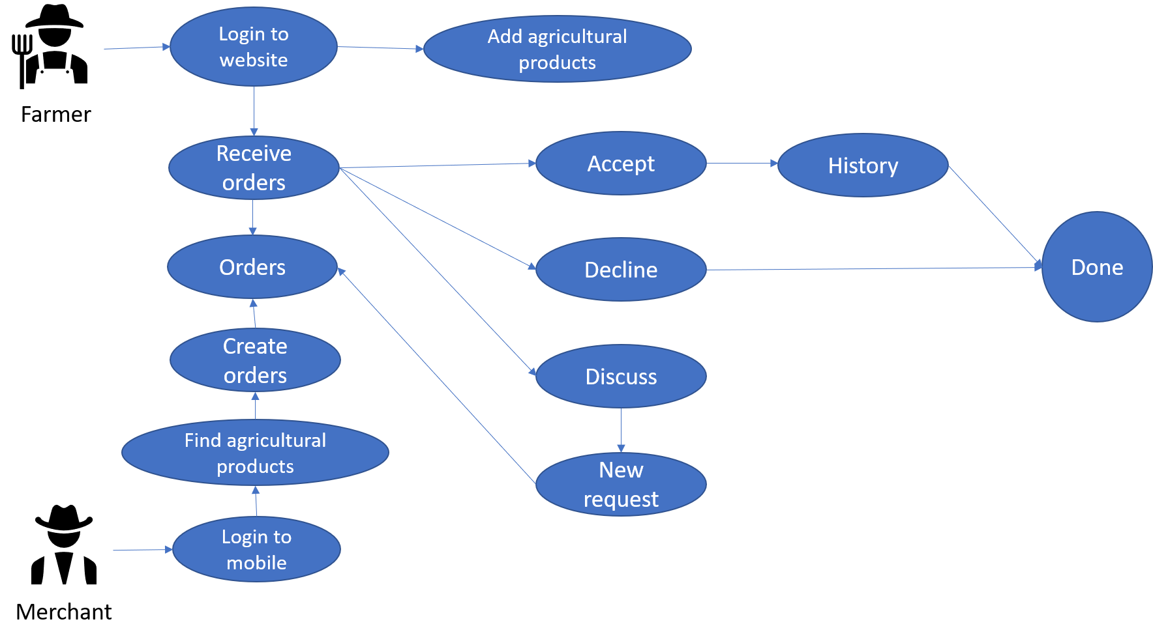

The portal allows farmers to first post agricultural items that are only available for a limited time, along with personal and contact information. The merchandiser's mobile application will then show the products, allowing them to select the ones that are best suited to their requirements.

The retailer will provide a pricing after determining the appropriate goods and quantity, and will then send the gardener a request along with contact details like their phone number, address, and shipping address. If the farmer accepts, he will click "Confirm," and the merchant will receive a successful notification. In contrast, if the farmer rejects the request, it will be declined and a notice of the rejection will be given to the merchant. The farmer may also recommend a different price, and the two parties may speak over the phone to discuss it. Once both parties have consented, the farmer can use the exchange button to display the form, fill it out with the new price, and submit it back to the merchant for confirmation before resuming the transaction. The merchant will receive updated information to review and validate. The deal is finished if everything goes according to plan and the farmer confirms; if not, it is canceled.

# CHAPTER 4. SYSTEM DESIGN

## 4.1. List of actors and usecases

### 4.1.1. Identify actors and use cases in use case diagrams

|  |  |
| --- | --- |
| **Actors** | **Usecases** |
| Merchant | - Login/Register  - Manage profile  - View the list of agricultural products  - View the farmers  - Search  - Orders  - Decision final deal price (if have)  - Delete the ordered agricultural product  - See the list of ordered agricultural products |
| Farmer | - Login/Register  - Manage profile  - Manage agricultural products  - Validate agricultural orders (Accept/Discuss/Decline)  - View agricultural products’ orders  - Deal new agricultural products’s price  - View other information |

### 4.1.2. Detailed description

|  |  |
| --- | --- |
| **Actors** | **Usecases** |
| Merchant | - Login  - Register  - Edit profile  - View the list of agricultural products  - View the farmers  - Search agricultural products  - Search farmer name  - Orders  - Decision final deal price (if have)  - Delete the ordered agricultural product  - See the list of ordered agricultural products  - See ordered history |
| Farmer | - Login  - Register  - Edit profile  - Add agricultural products  - Delete agricultural products  - Accept agricultural orders  - Discuss agricultural orders  - Decline agricultural orders  - View agricultural products’ orders  - Deal new agricultural products’s price  - View agricultural news  - View agricultural videos  - View weather forecast |

### 4.1.3. Usecase summary

|  |  |  |
| --- | --- | --- |
| **No** | **Usecases** | **Actors** |
| 1 | Login | Merchant, Farmer |
| 2 | Edit account | Merchant, Farmer |
| 3 | Register | Merchant, Farmer |
| 4 | View list of agricultural products | Merchant |
| 5 | View list of agricultural products that farmers own | Merchant, Farmers |
| 6 | Search | Merchant, Farmer |
| 7 | Order | Merchant |
| 8 | Cancel the ordered agricultural product | Merchant |
| 9 | See the list of ordered agricultural products | Merchant, Farmer |
| 10 | Deal new agricultural products’s price | Farmer |
| 11 | Decision final deal price | Merchant |
| 12 | Manage agricultural product | Farmer |
| 13 | Validate agricultural orders (Accept/Discuss/Decline) | Farmer |

## 4.2. Usecase diagram

**\*General usecase diagram**

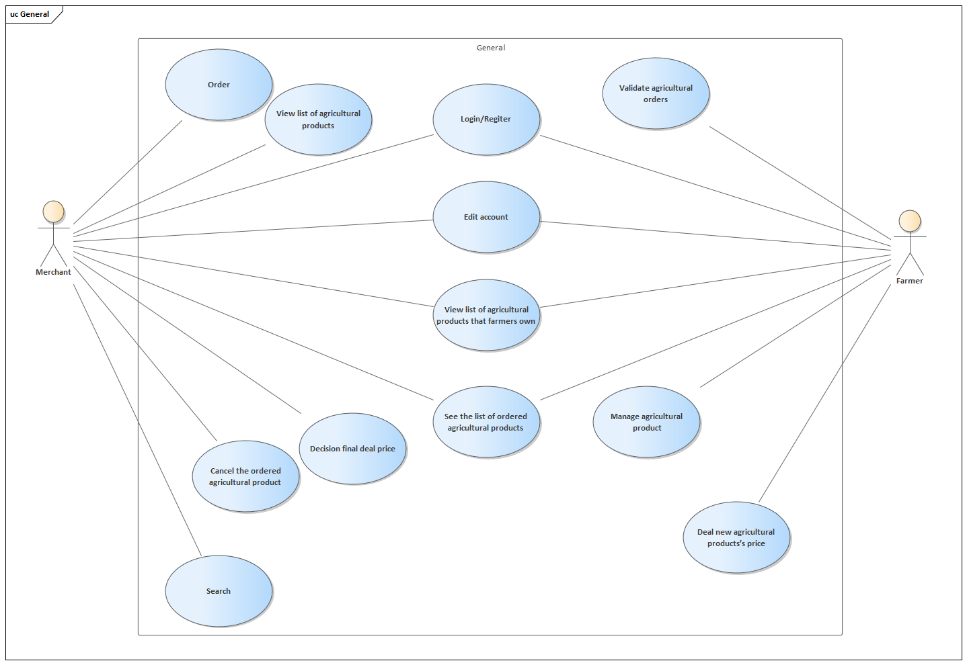

**\*Usecase for Merchant**

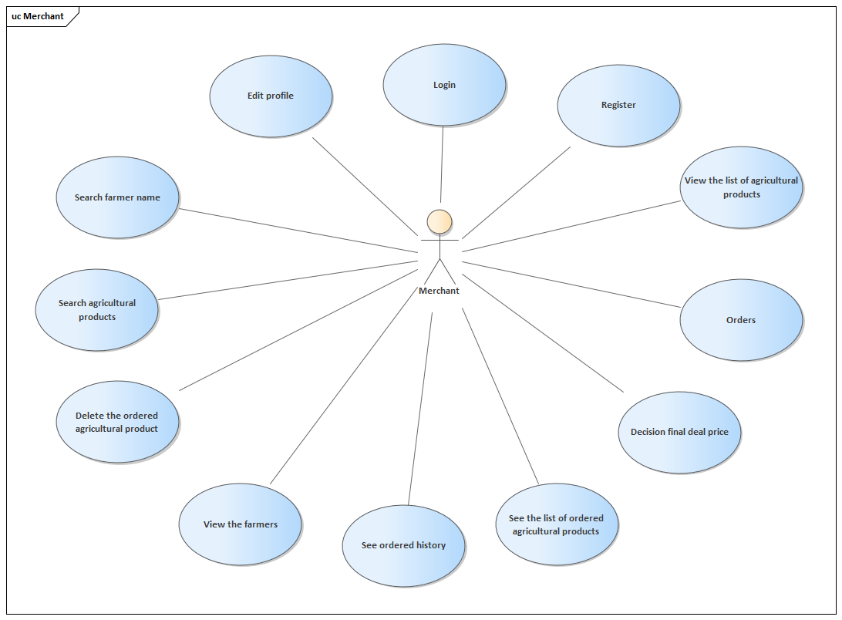

**\*Usecase for farmer**

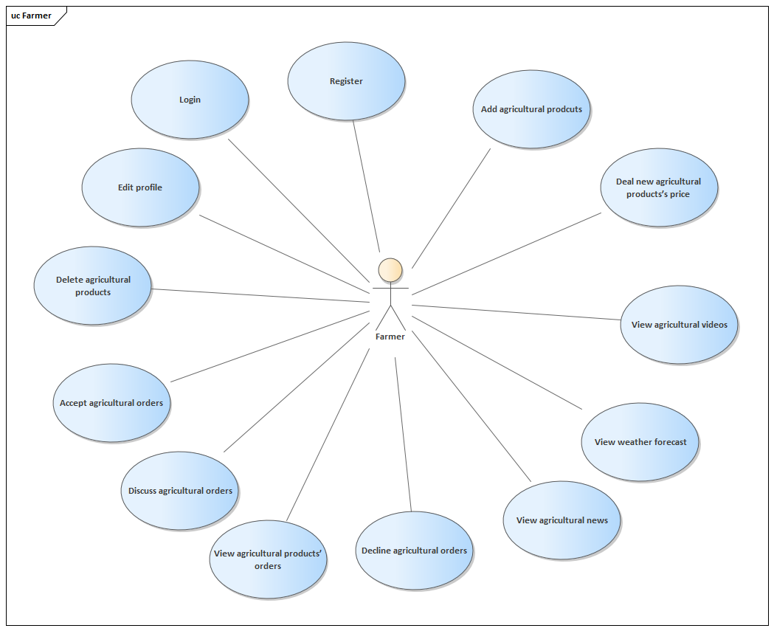

## 4.3. Usecase specifications

1. **Description of Login Use Case**

|  |  |
| --- | --- |
| **Use Case Login** | |
| **Description** | Actor logs into the system |
| **Actors** | Merchant (m), Farmer (f) |
| **Precondition** | When the actor wants to log into the system to do something |
| **Steps** | 1. Actor open the mobile (m) / web (f) 2. Enter username and password into login form 3. Press login button 4. The system sends information to the database for validation. 5. Password and username are correct and the actor will log into the system with his/her correct role. |

1. **Description of Edit Account Use Case**

|  |  |  |
| --- | --- | --- |
| **Use Case Edit Account** | | |
| **Description** | Actor edits the information of actor’s account |
| **Actors** | Merchant (m), Farmer (f) |
| **Precondition** | When the actor wants to change the information on edit account |
| **Steps** | 1. Actor open the mobile (m) / web (f) 2. Actor go to the setting information. 3. Actor can change the information (that needs to be checked for validation). 4. Actor click on the Change button to update the new information and the data will be saved. |

1. **Description of Register Use Case**

|  |  |
| --- | --- |
| **Use Case Register** | |
| **Description** | Actor registers an account in the system |
| **Actors** | Merchant (m), Farmer (f) |
| **Precondition** | When the actor wants to have an account in the system to become a Merchant or a Farmer. |
| **Steps** | **(1)** Actor open the mobile (m) / web (f).  **(2)** Actor click to the Register (Sign up) Button and will be navigated to the Register Screen (Page).  **(3)** Actor need to fill in all required information and have that information checked for validation before sign up.  **(4)** Actor click on the Register to create a new account (after checking whether the account has existed or the password is correct or not). |

1. **Description of View List of Agricultural products Use Case**

|  |  |
| --- | --- |
| **Use View List of Agricultural products** | |
| **Description** | Actor sees a list of all Agricultural products. |
| **Actors** | Merchant (m) |
| **Precondition** | When the actor wants to see all Agricultural products. |
| **Steps** | **(1)** Actor open the mobile (m)  **(2)** Actor need to login the app and after login sucessful actor will be move to the Home Screen.  **(3)** Actor click on the Explore Tab at the bottom and will see the catrgory and a list of products. |

1. **Description of View list of agricultural products that farmers own Use Case**

|  |  |
| --- | --- |
| **Use Case View list of agricultural products that farmers own** | |
| **Description** | Actor sees all Agricultural products of a specific Farmer. |
| **Actors** | Merchant (m), Farmer (f) |
| **Precondition** | When the actor wants to see all Agricultural products of a specific Farmer. |
| **Steps** | **(1)** Actor open the mobile (m) / web (f)  Mobile:  **(2)** In the Explore Tab, Actor can input the name of the farm and search.  **(3)** The results will be shown (including the farm) the actor can click into the farm.  **(4)** The products of that farm can be shown on that farm detail screen. |

1. **Description of Search**

|  |  |
| --- | --- |
| **Use Search** | |
| **Description** | Actor search for a specific Agricultural product in the system. |
| **Actors** | Merchant (m), Farmer (f) |
| **Precondition** | When the actor wants to see a specific Agricultural product in the system. |
| **Steps** | **(1)** Actor open the mobile (m) / web (f)  Mobile:  **(2)** In the Explore Tab, Actor can input the name of the product and search.  **(3)** The results will be shown (including the product) the actor can click into the product.  **(4)** The product’s detail of that farm can be shown on that product detail screen. |

1. **Description of Order**

|  |  |
| --- | --- |
| **Use Case Order** | |
| **Description** | Actor order an agricultural product. |
| **Actors** | Merchant (m) |
| **Precondition** | When the actor wants to buy an agricultural product in the system. |
| **Steps** | **(1)** Actor open the mobile (m)  **(2)** When found the need agricultural products, actor can order button  **(3)** The result will be showed in order screen. |

1. **Description of Cancel the ordered agricultural product**

|  |  |
| --- | --- |
| **Use Case Cancel the ordered agricultural product** | |
| **Description** | Actor cancels an order of agricultural product. |
| **Actors** | Merchant (m) |
| **Precondition** | When the actor does not want the agricultural product. |
| **Steps** | **(1)** Actor open the mobile  **(2)** In the Waiting Order in the ‘Me’ Tab Actor can view the order that had been sent.  **(3)** Actor can choose that order to view the detail screen of that order and choose the deleted button in the top right corner. |

1. **Description of See the list of ordered agricultural products**

|  |  |
| --- | --- |
| **Use Case See the list of ordered agricultural products** | |
| **Description** | Actor sees the list of ordered agricultural products. |
| **Actors** | Merchant (m), Farmer (f) |
| **Precondition** | When the actor sees the list of ordered agricultural products. |
| **Steps** | **(1)** Actor open the mobile (m) / web (f)  Mobile:  **(2)** In the Waiting Order in the ‘Me’ Tab Actor can view the order that had been sent.  Web:  **(3)** Open Order page to see. |

**10.** **Description of Deal new agricultural products’s price**

|  |  |
| --- | --- |
| **Use Case Deal new agricultural products’s price** | |
| **Description** | Actor accepts the deal of new agricultural products’s price from the merchant. |
| **Actors** | Farmer (f) |
| **Precondition** | When the actor deals the new agricultural products’s price from the merchant. |
| **Steps** | **(1)** Actor open the web (f)  **(2)** Click the discuss button in the order list.  **(3)** A form to deal new price will be show for actor to fill information.  **(4)** Click request button to sent the request. |

**11.** **Description of Decision final deal price**

|  |  |
| --- | --- |
| **Use Case Decision final deal price** | |
| **Description** | Actor accepts the final deal price from the farmer. |
| **Actors** | Merchant (m) |
| **Precondition** | When the actor deals the final price of farmer’s agricultural products. |
| **Steps** | **(1)** Actor open the mobile (m).  **(2)** If farmers deal new price, a message will be sent to actor.  **(3)** The request will be showed in waiting screen with the mark “dealing” |

**12.** **Description of Manage agricultural product**

|  |  |
| --- | --- |
| **Use Case Manage agricultural product** | |
| **Description** | Actor manages actor’s agricultural products. |
| **Actors** | Farmer (f) |
| **Precondition** | When the actor wants to change actor’s agricultural products. |
| **Steps** | **(1)** Actor open the mobile web (f)  **(2)** Open agricultural product page.  **(3)** Fill all information to add new product or delete product. |

**13.** **Description of Validate agricultural products**

|  |  |
| --- | --- |
| **Use Case Validate agricultural products** | |
| **Description** | Actor validates the actor’s agricultural products. |
| **Actors** | Farmer (f) |
| **Precondition** | When the actor validates the actor’s agricultural products. |
| **Steps** | **(1)** Actor open the web (f)  **(2)** Open order page.  **(3)** Here the actor can accept/discuss/decline the orders. |

## 4.4. Database design

### 4.4.1. Database table

***1. District***

|  |  |  |  |
| --- | --- | --- | --- |
| **No** | **Property** | **Type** | **Description** |
| 1 | id | int | Id |
| 2 | name | Varchar (255) | District Name |
| 3 | province_id | int | Province Id |

***2. Fruit***

|  |  |  |  |
| --- | --- | --- | --- |
| **No** | **Property** | **Type** | **Description** |
| 1 | id | int | Id |
| 2 | date | date | Date |
| 3 | description | Varchar (255) | Description |
| 4 | name | Varchar (255) | Name |
| 5 | popular | Bit (1) | Popular |
| 6 | season | Varchar (255) | Season |
| 7 | unit | Varchar (255) | Unit |
| 8 | userid | int | User Id |
| 9 | weight | float | Weight |

***3. Fruit image***

|  |  |  |  |
| --- | --- | --- | --- |
| **No** | **Property** | **Type** | **Description** |
| 1 | id | int | Id |
| 2 | fruit_id | int | Fruit Id |
| 3 | url | Varchar (255) | Url Of Image |

***4. History***

|  |  |  |  |
| --- | --- | --- | --- |
| **No** | **Property** | **Type** | **Description** |
| 1 | id | int | Id |
| 2 | amount | int | Amount |
| 3 | date | date | Date |
| 4 | farmer_id | int | Farmer Id |
| 5 | fruit_id | int | Fruit Id |
| 6 | merchant_id | int | Merchant Id |
| 7 | price | float | Price |
| 8 | transport | bool | Transport (Yes/No) |

***6. Location***

|  |  |  |  |
| --- | --- | --- | --- |
| **No** | **Property** | **Type** | **Description** |
| 1 | id | int | Id |
| 2 | address | Varchar (255) | Address |
| 3 | ward_id | int | Ward Id |

***7. News***

|  |  |  |  |
| --- | --- | --- | --- |
| **No** | **Columm** | **Type** | **Description** |
| 1 | id | int | Id |
| 2 | author | Varchar (255) | Author |
| 3 | category | Varchar (255) | Category |
| 4 | content | Varchar (255) | Content |
| 5 | date | date | Date |
| 6 | image_banner | Varchar (255) | Image Banner |
| 7 | image_content | Varchar (255) | Image Content |
| 8 | tittle | Varchar (255) | Tittle |

***8. Order***

|  |  |  |  |
| --- | --- | --- | --- |
| **No** | **Property** | **Type** | **Description** |
| 1 | id | int | Id |
| 2 | amount | int | Amount |
| 3 | date | date | Date |
| 4 | deal_amount | int | Deal Amount |
| 5 | deal_price | float | Deal Price |
| 6 | farmer_id | int | Farmer Id |
| 7 | fruit_id | int | Fruit Id |
| 8 | merchant_id | int | Merchant Id |
| 9 | price | float | Price |
| 10 | status_id | int | Status Id |
| 11 | transport | bool | Transport |

***9. Province***

|  |  |  |  |
| --- | --- | --- | --- |
| **No** | **Property** | **Type** | **Description** |
| 1 | id | int | Id |
| 2 | name | Varchar (255) | Name |

***10. Role***

|  |  |  |  |
| --- | --- | --- | --- |
| **No** | **Property** | **Type** | **Description** |
| 1 | id | int | Id |
| 2 | name | Varchar (255) | Name |

***11. Status product***

|  |  |  |  |
| --- | --- | --- | --- |
| **No** | **Property** | **Type** | **Description** |
| 1 | id | int | Id |
| 2 | name | Varchar (255) | Name |

***12. Status user***

|  |  |  |  |
| --- | --- | --- | --- |
| **No** | **Property** | **Type** | **Description** |
| 1 | id | int | Id |
| 2 | name | Varchar (255) | Name |

***13. User***

|  |  |  |  |
| --- | --- | --- | --- |
| **No** | **Property** | **Type** | **Description** |
| 1 | id | int | Id |
| 2 | avatar | Varchar (255) | Avatar |
| 3 | birth_day | date | Birthday |
| 4 | create_day | date | Create Day |
| 5 | description | Varchar (255) | Description |
| 6 | email | Varchar (255) | Email |
| 7 | first_name | Varchar (255) | First Name |
| 8 | last_name | Varchar (255) | Last Name |
| 9 | location_id | int | Location Id |
| 10 | password | Varchar (255) | Password |
| 11 | phone | Varchar (255) | Phone |
| 12 | status_id | int | Status Id |
| 13 | username | Varchar (255) | Username |

***14. User role***

|  |  |  |  |
| --- | --- | --- | --- |
| **No** | **Property** | **Type** | **Description** |
| 1 | role_id | int | Role Id |
| 2 | user_id | int | User Id |

***15. Role***

|  |  |  |  |
| --- | --- | --- | --- |
| **No** | **Property** | **Type** | **Description** |
| 1 | id | int | Id |
| 2 | district_id | int | District Id |
| 3 | name | Varchar (255) | Name |

### 4.4.2. Relational diagram

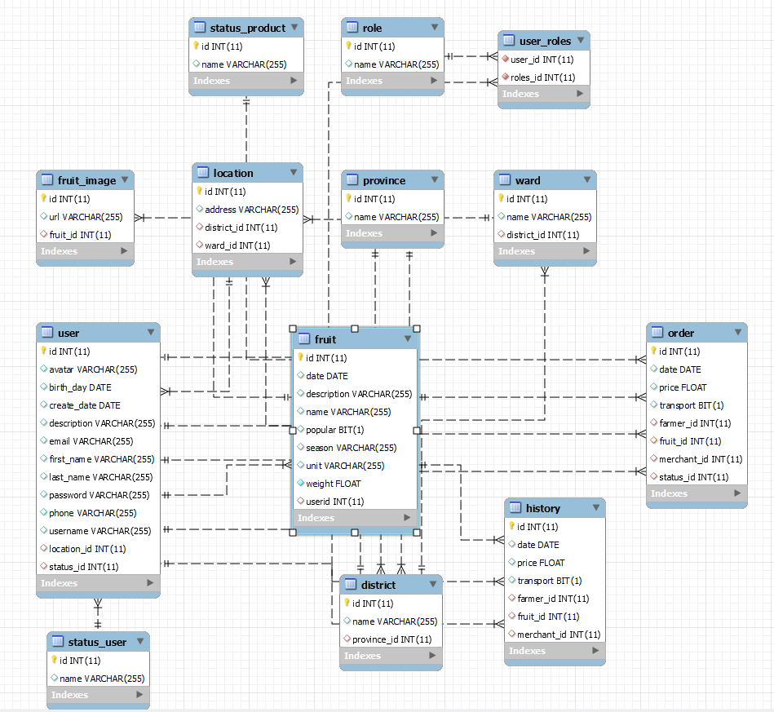

## 4.5. User interface

### 4.5.1. Mobile for merchant

***1. Login screen***

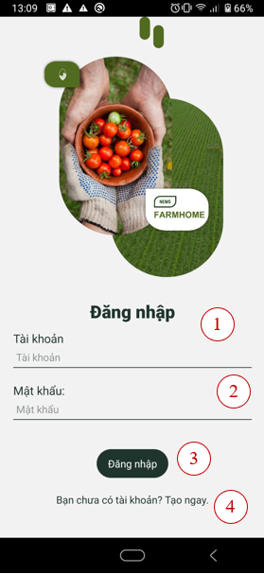

|  |  |  |
| --- | --- | --- |
| Order | Type | Meaning |
| 1 | Input | Input Username for login |
| 2 | Input | Input Password for login |
| 3 | Button | Login |
| 4 | Button | Move to Signup screen |

***2. Signup screen***

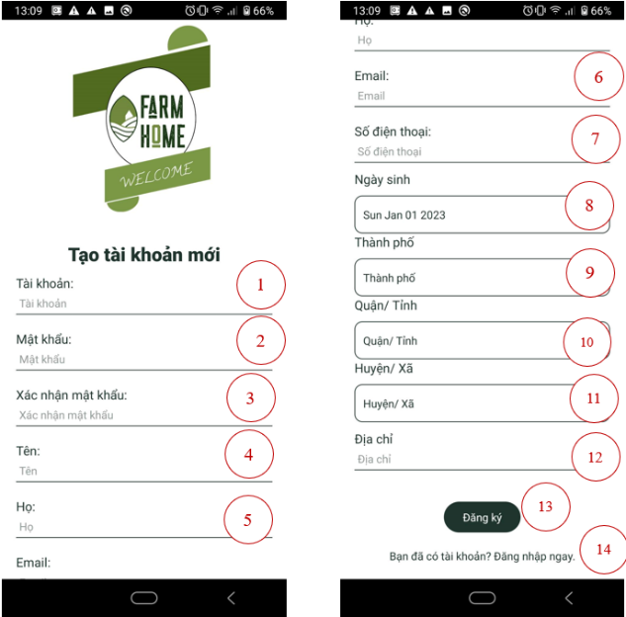

|  |  |  |
| --- | --- | --- |
| Order | Type | Meaning |
| 1 | Input | Input Username for signup |
| 2 | Input | Input Password for signup |
| 3 | Input | Input Confirm Password for signup |
| 4 | Input | Input First Name for signup |
| 5 | Input | Input Last Name for signup |
| 6 | Input | Input Email for signup |
| 7 | Input | Input Phone for signup |
| 8 | Input | Input Birth Date for signup |
| 9 | Input | Input City for signup |
| 10 | Input | Input District for signup |
| 11 | Input | Input Ward for signup |
| 12 | Input | Input Address for signup |
| 13 | Button | Signup Account |
| 14 | Button | Move to Login screen. |

***3. Home screen***

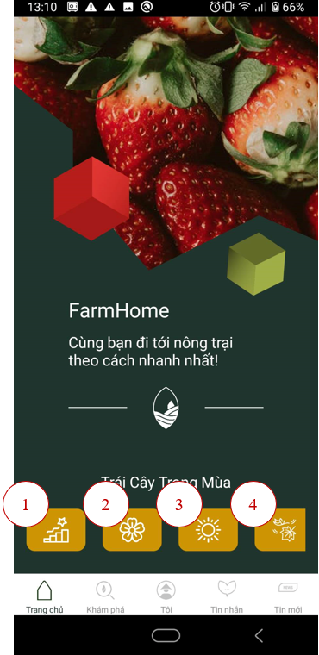

|  |  |  |
| --- | --- | --- |
| Order | Type | Meaning |
| 1 | Button | Move to Search screen with option “Hot” in filter |
| 2 | Button | Move to Search screen with option “Spring” in filter |
| 3 | Button | Move to Search screen with option “Summer” in filter |
| 4 | Button | Move to Search screen with option “Fall” in filter |

***4. Explore screen***

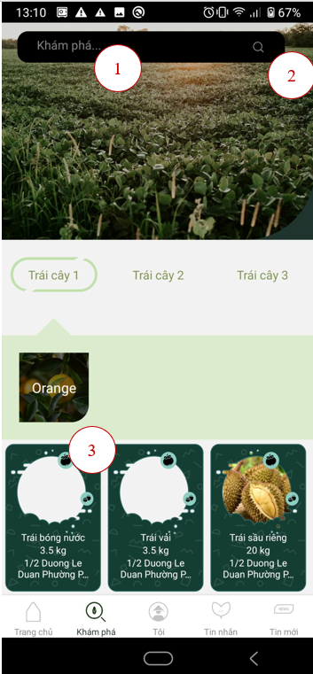

|  |  |  |
| --- | --- | --- |
| Order | Type | Meaning |
| 1 | Input | Input the name for searching products |
| 2 | Button | Move to Search screen with products contain the string |
| 3 | Button | Move to the Product detail of the selected product |

***5. Search screen***

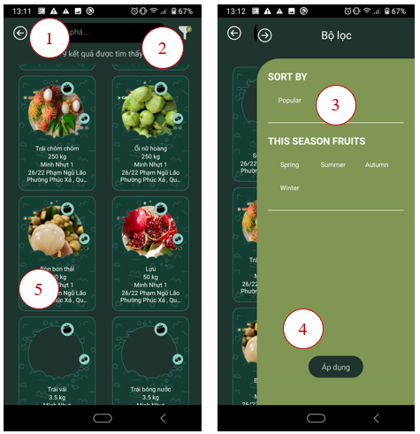

|  |  |  |
| --- | --- | --- |
| Order | Type | Meaning |
| 1 | Input | Input the name for searching products |
| 2 | Button | Open Filter |
| 3 | Button | Choose filter options |
| 4 | Button | Apply the filter and load the product list |
| 5 | Button | Move to the Product detail of the selected product |

***6. Product detail screen***

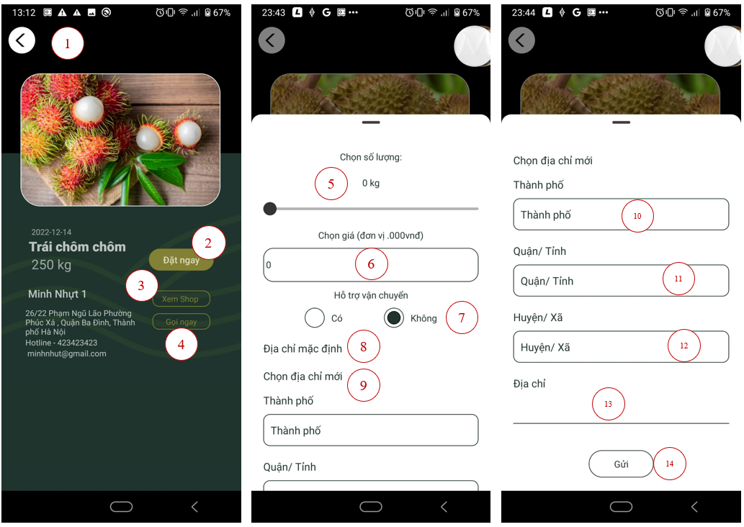

|  |  |  |
| --- | --- | --- |
| Order | Type | Meaning |
| 1 | Button | Back to the previous screen |
| 2 | Button | Open the form for ordering |
| 3 | Button | Go to the store detail |
| 4 | Button | Open the phone screen with phone number |
| 5 | Slider | Choose the amount for ordering |
| 6 | Input | Choose the price for one unit of that fruit |
| 7 | Radio Button | Choose for Transport Supporting |
| 8 | Button | Choose the default address for Transport delivery |
| 9 | Button | Choose the new address for Transport delivery |
| 10 | Input | Input the City for the new address |
| 11 | Input | Input District for signup |
| 12 | Input | Input Ward for signup |
| 13 | Input | Input Address for signup |
| 14 | Button | Order |

***7. Store detail screen***

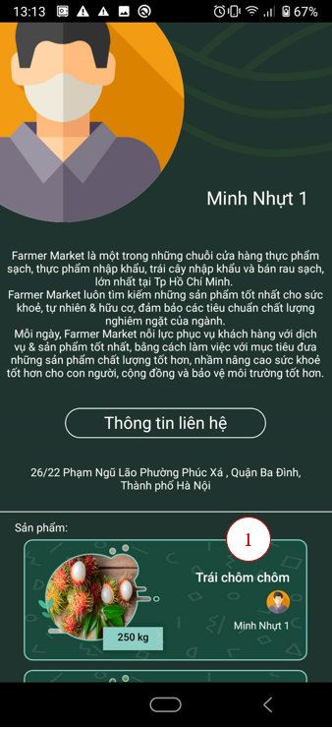

|  |  |  |
| --- | --- | --- |
| Order | Type | Meaning |
| 1 | Button | Move to the product detail screen |

***8. Setting screen***

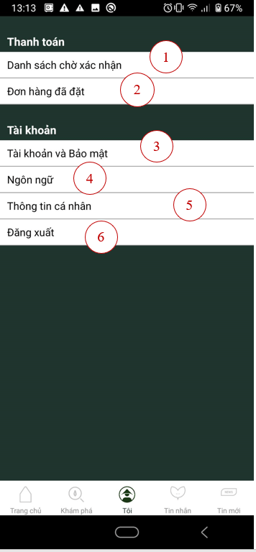

|  |  |  |
| --- | --- | --- |
| Order | Type | Meaning |
| 1 | Button | Move to the Order Requests screen |
| 2 | Button | Move to the History screen |
| 3 | Button | Move to the Changing Password screen |
| 4 | Button | Move to the Changing Language screen |
| 5 | Button | Move to the Profile screen |
| 6 | Button | Logout |

***7. Order List screen***

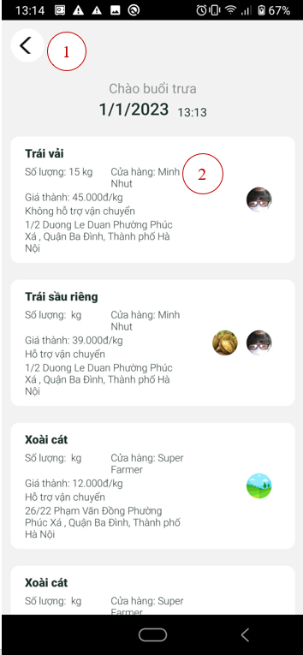

|  |  |  |
| --- | --- | --- |
| Order | Type | Meaning |
| 1 | Button | Move back to the previous screen |
| 2 | Button | Move to the Order Detail screen |

***8. Order Detail screen***

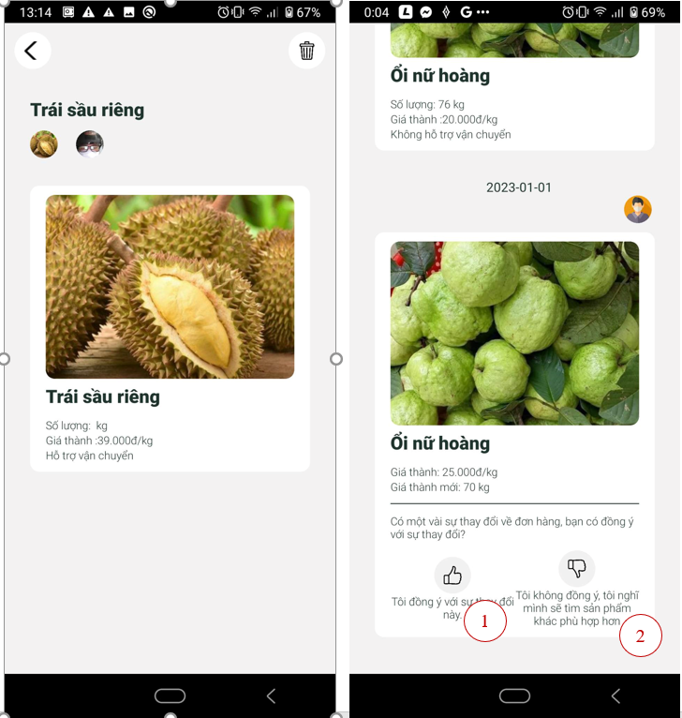

|  |  |  |
| --- | --- | --- |
| Order | Type | Meaning |
| 1 | Button | Accept the order change |
| 2 | Button | Decline the order change |

***9. Change Password screen***

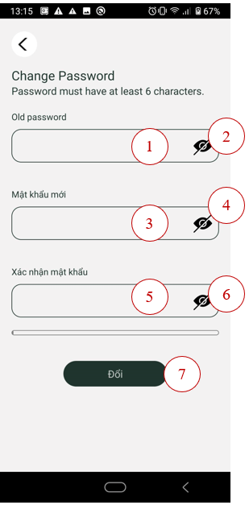

|  |  |  |
| --- | --- | --- |
| Order | Type | Meaning |
| 1 | Input | Input the old password |
| 2 | Button | Make the old password visible |
| 3 | Input | Input the new password |
| 4 | Button | Make the new password visible |
| 5 | Input | Input the confirm new password |
| 6 | Button | Make the confirm new password visible |
| 7 | Button | Change password |

***10. Change Language screen***

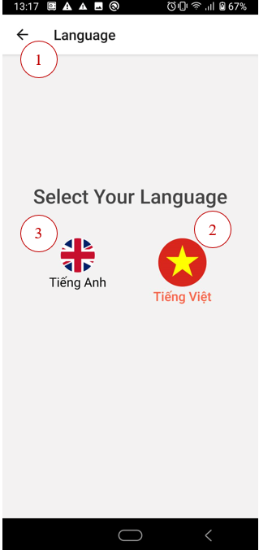

|  |  |  |
| --- | --- | --- |
| Order | Type | Meaning |
| 1 | Button | Move to the previous screen |
| 2 | Button | Set the language to Vietnamses |
| 3 | Button | Set the language to English |

***11. User Detail screen***

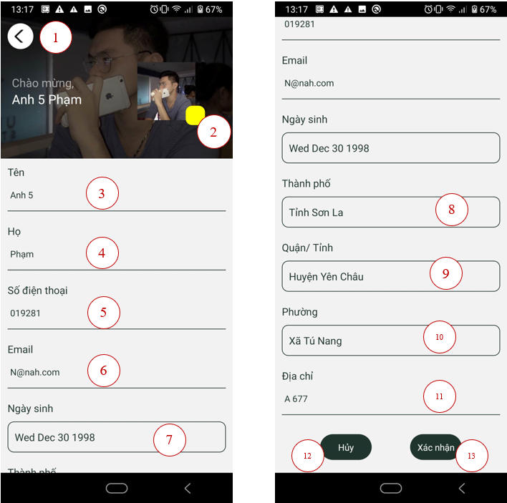

|  |  |  |
| --- | --- | --- |
| Order | Type | Meaning |
| 1 | Button | Move to the previous screen |
| 2 | Button | Open tbe library to choose the image |
| 3 | Input | Change the first name |
| 4 | Input | Change the last name |
| 5 | Input | Change the phone |
| 6 | Input | Change the email |
| 7 | Input | Change the birhtdate |
| 8 | Input | Change the city |
| 9 | Input | Change the district |
| 10 | Input | Change the ward |
| 11 | Input | Change the address |
| 12 | Button | Back to the previous screen |
| 13 | Button | Change the the user information |

***12. History List***

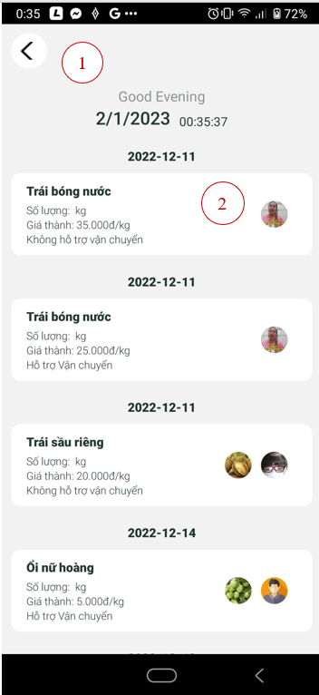

|  |  |  |
| --- | --- | --- |
| Order | Type | Meaning |
| 1 | Button | Move back to the previous screen |
| 2 | Button | Move to the History Detail screen |

***13. History Detail screen***

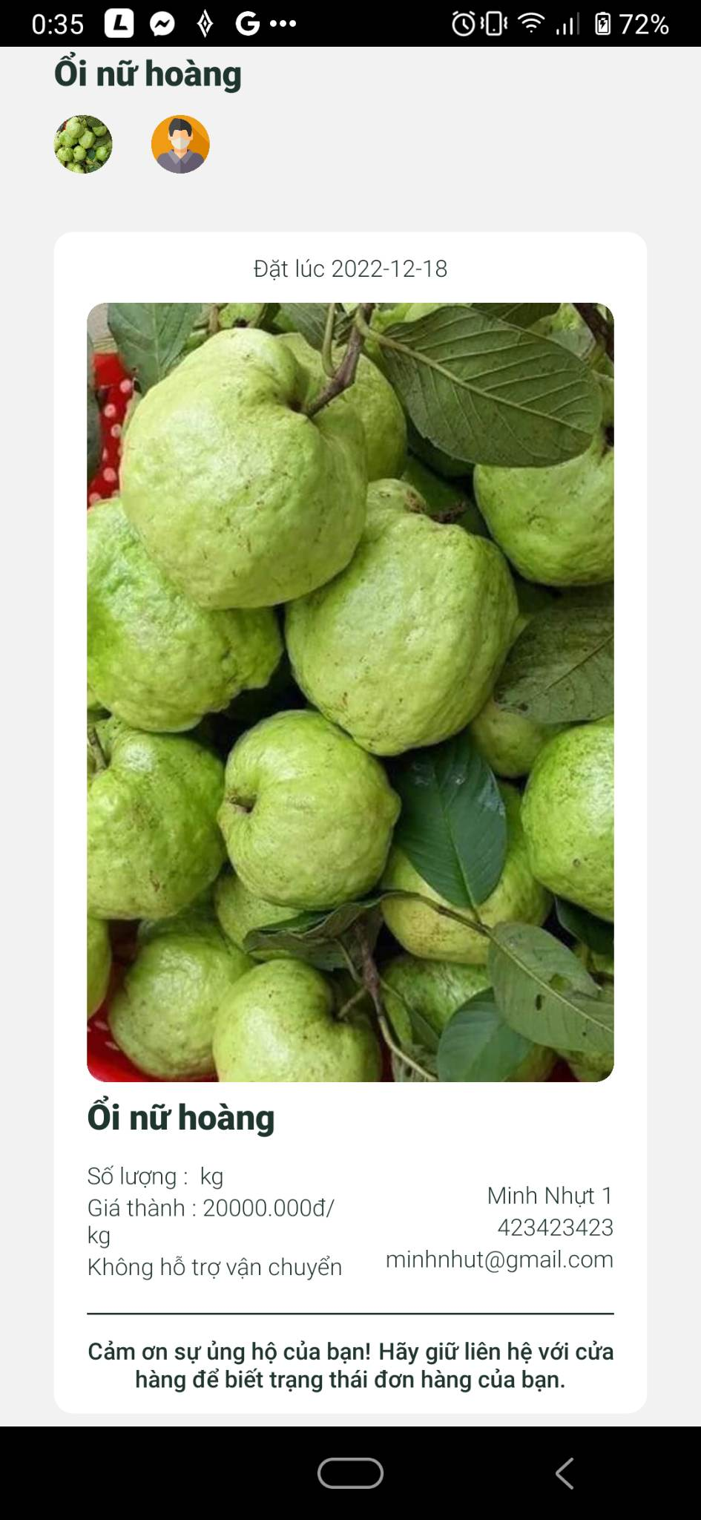

### 4.5.2. Website for farmer

***1. Login page***

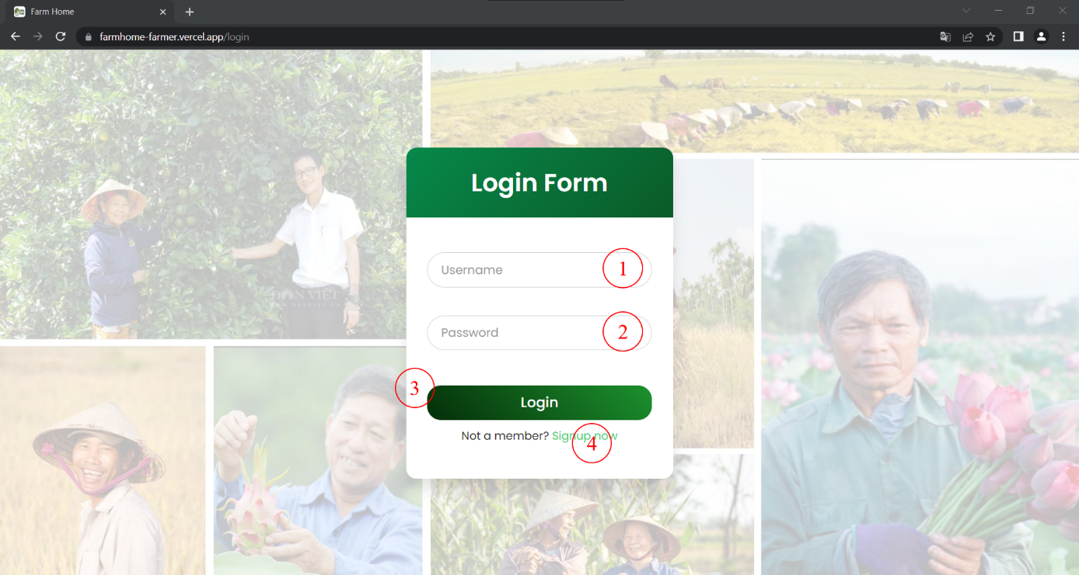

|  |  |  |
| --- | --- | --- |
| Order | Type | Meaning |
| 1 | Input | Input user name |
| 2 | Input | Input password |
| 3 | Button | Click to login |
| 4 | Button | Click to go to register |

***2. Register page (not available now)***

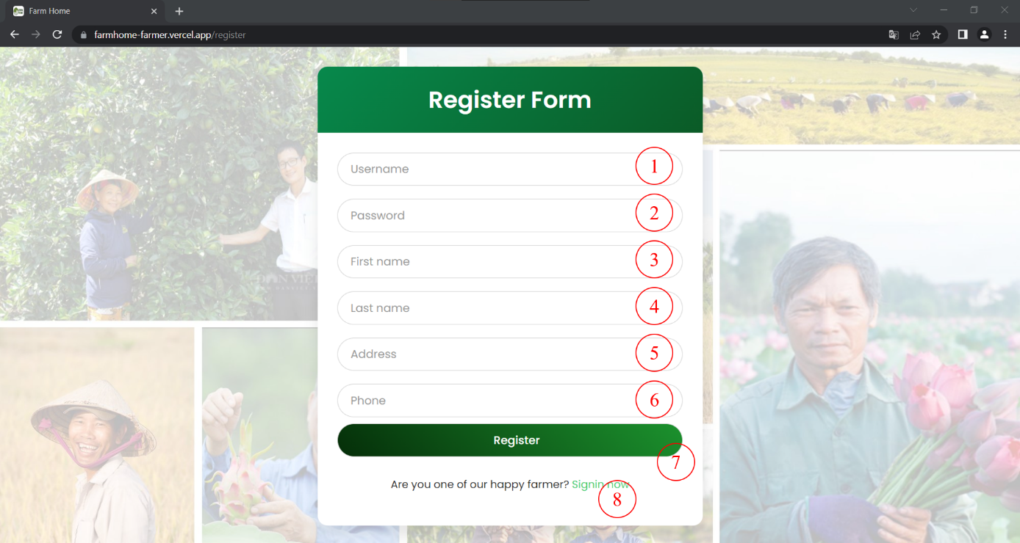

***3. Home page***

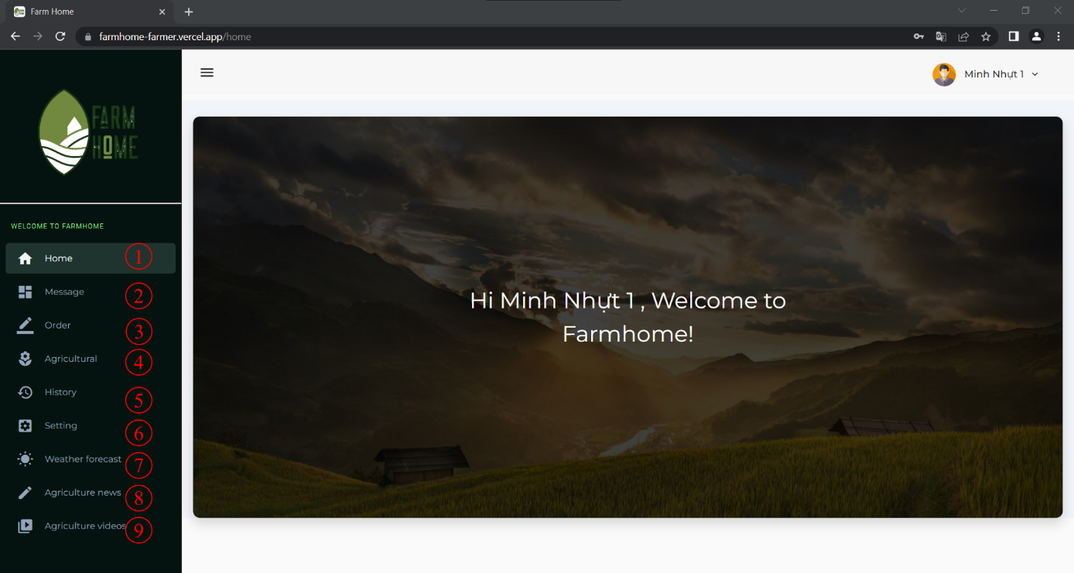

|  |  |  |
| --- | --- | --- |
| Order | Type | Meaning |
| 1 | Hyperlink | Move to the direct page |
| 2 | Hyperlink |
| 3 | Hyperlink |
| 4 | Hyperlink |
| 5 | Hyperlink |
| 6 | Hyperlink |
| 7 | Hyperlink |
| 8 | Hyperlink |
| 9 | Hyperlink |

***4. Order page***

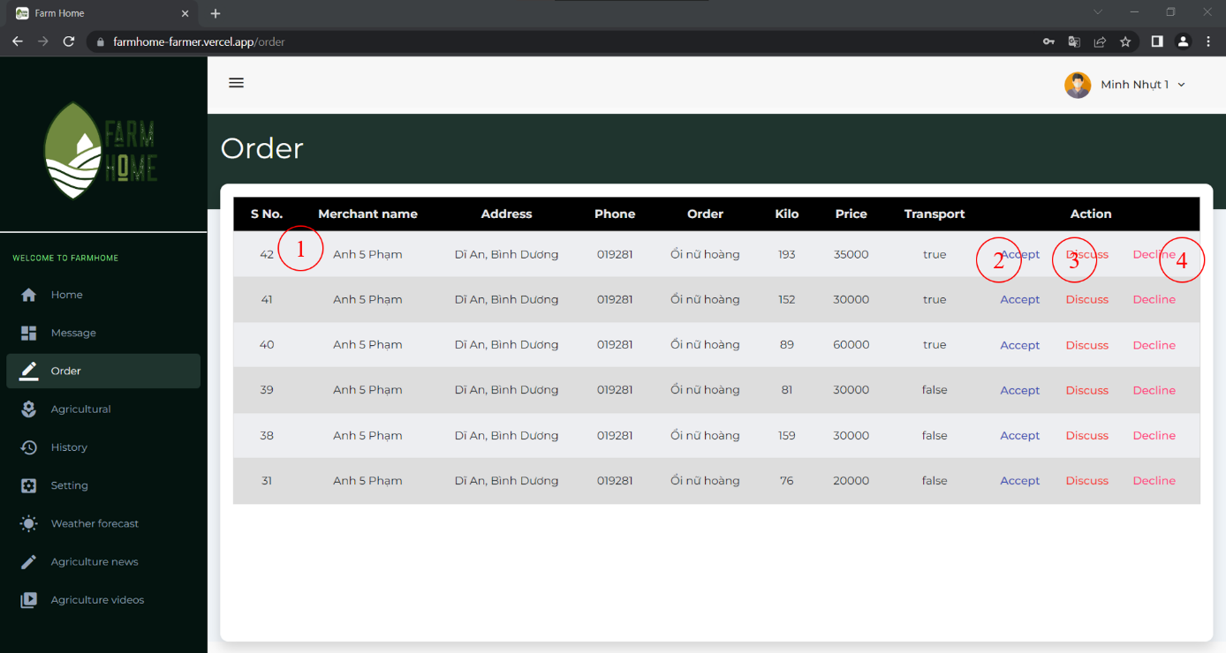

|  |  |  |
| --- | --- | --- |
| Order | Type | Meaning |
| 1 | Table | Show table of order |
| 2 | Button | Click to accept |
| 3 | Button | Click to disscuss |
| 4 | Button | Click to decline |

***5. Agricultural product page***

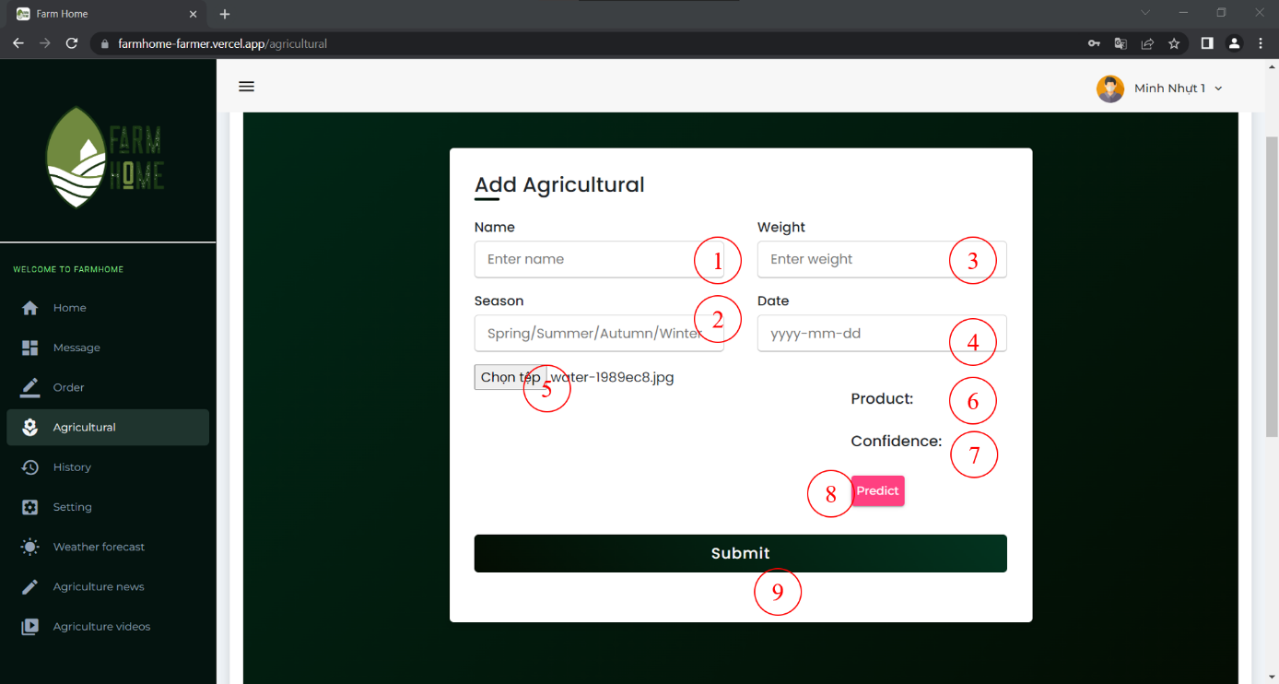

|  |  |  |
| --- | --- | --- |
| Order | Type | Meaning |
| 1 | Input | Input name |
| 2 | Input | Input season |
| 3 | Input | Input weight |
| 4 | Input | Input date |
| 5 | Button | Choose image |
| 6 | Text | Show prediction |
| 7 | Text | Show confidence |
| 8 | Button | Click to predict |
| 9 | Button | Click to submit |

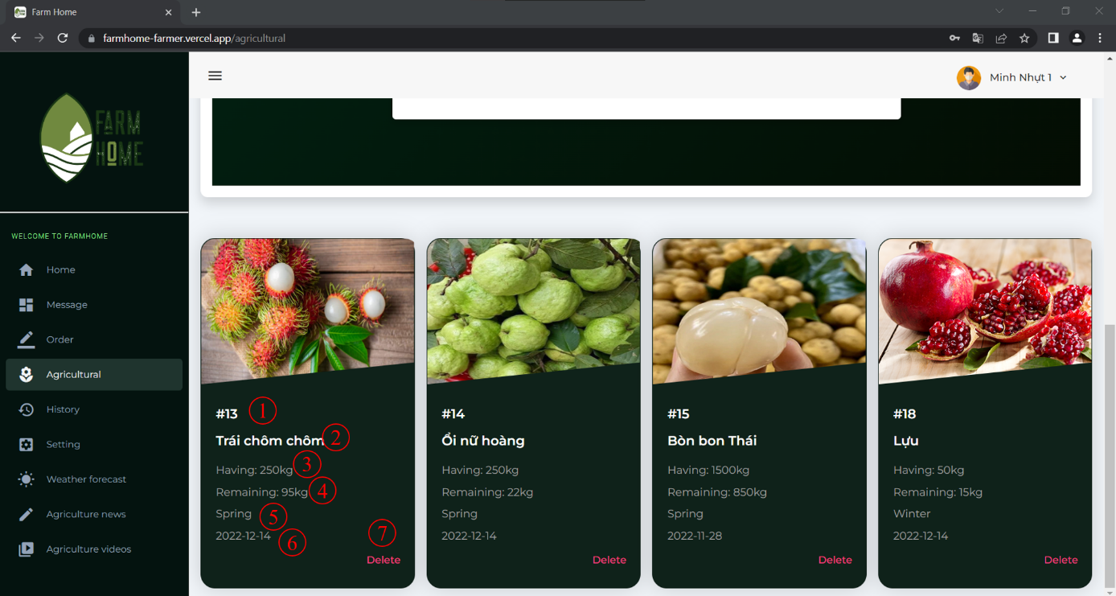

|  |  |  |
| --- | --- | --- |
| 7 | Button | Click to delete fruit |

***6. History page***

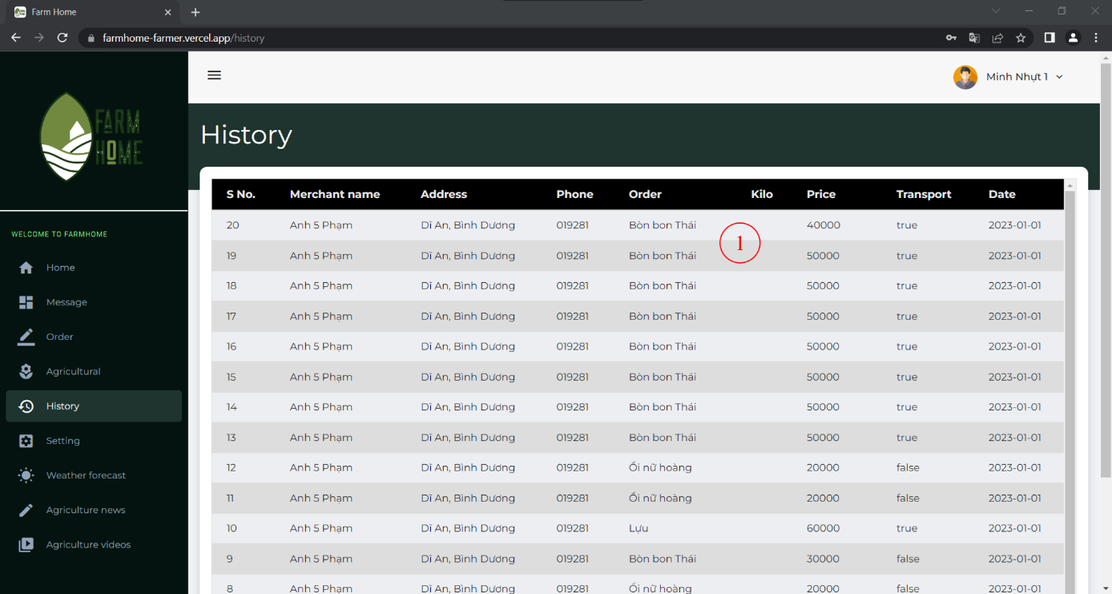

# CHAPTER 5: SYSTEM ARCHITECTURE AND TECHNOLOGY

## 5.1. Overall architecture of the system

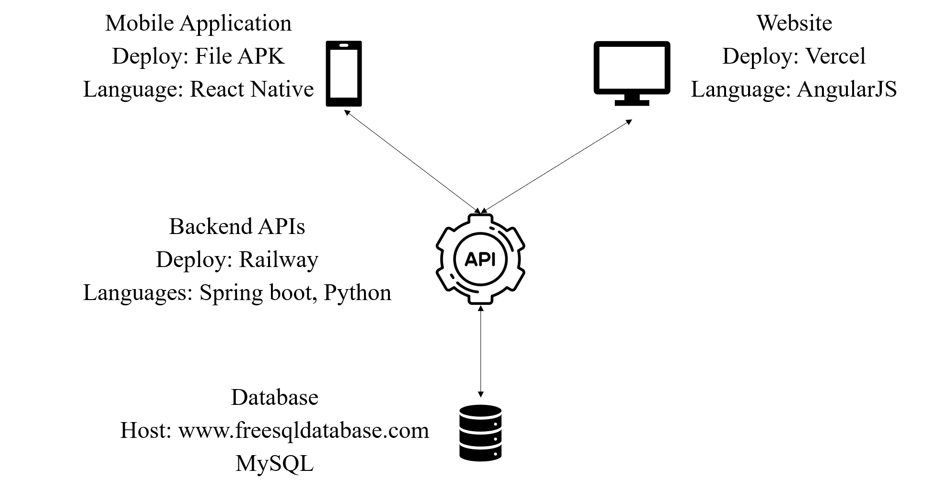

## 5.2. Tensorflow

Dataset source: Kaggle – Fruits and Vegetables Image Recognition Dataset

https://www.kaggle.com/datasets/kritikseth/fruit-and-vegetable-image-recognition

Use Shallow Neural Networks

Number of pictures: 3193

Number of different labels: 36

Labels: ['grapes' 'pomegranate' 'banana' 'carrot' 'garlic' 'onion' 'pineapple'

'orange' 'capsicum' 'jalepeno' 'paprika' 'watermelon' 'raddish' 'lettuce'

'spinach' 'tomato' 'sweetpotato' 'cauliflower' 'bell pepper' 'peas'

'lemon' 'kiwi' 'chilli pepper' 'cabbage' 'turnip' 'eggplant' 'potato'

'soy beans' 'pear' 'mango' 'beetroot' 'sweetcorn' 'cucumber' 'corn'

'apple' 'ginger']

Data processing:

- Use tf.keras preprocessing.image.ImageDataGenerator with config:

dataframe=train_df,

x_col='Filepath',

y_col='Label',

target_size=(224, 224),

color_mode='rgb',

class_mode='categorical',

batch_size=32,

shuffle=True,

seed=0,

rotation_range=30,

zoom_range=0.15,

width_shift_range=0.2,

height_shift_range=0.2,

shear_range=0.15,

horizontal_flip=True,

fill_mode="nearest"

Model training:

- 2 layers of Dense with 128 units and Rectified Linear Unit activation

- output layer: 36 units and softmax activation

- model compile:

optimizer='adam',

loss='categorical_crossentropy',

metrics=['accuracy']

- model train:

Batch_size = 32

Epochs = 5

EarlyStopping(monitor=“val_loss”, patience=2, restore_best_weights=True)

- Accuracy: 0.9417

- loss: 0.1790

- val_accuracy: 0.9521

- val_loss: 0.1094

# CHAPTER 6. SOFTWARE TESTING

## 6.1. Introduction

### 6.1.1. Purpose

This test plan describes the testing approach and overall framework that will drive the testing of our group application include web application for farmers and mobile app for merchants.

Test Strategy: rules the test will be based on, including the givens of the project (e.g.: start / end dates, objectives, assumptions); description of the process to set up a valid test (e.g.: entry / exit criteria, creation of test cases, specific tasks to perform, scheduling, data strategy).

Execution Strategy: describes how the test will be performed and process to identify and report defects, and to fix and implement fixes.

Test Management: process to handle the logistics of the test and all the events that come up during execution (e.g.: communications, escalation procedures, risk and mitigation, team roster).

### 6.1.2. Project overview

The goal of the system is that farmers can post agricultural products that are available for a specified period of time on the platform with personal information as well as contact information. The products will then be displayed on the mobile application on the merchant's side so that they can choose the right products for their needs. When choosing the right product and quantity, the merchant will offer a price and send that request to the farmer with information such as phone number, address, and shipping. If the farmer agrees, it will click confirm and a successful notification will be sent to the merchant. Conversely, if the farmer does not agree with the request, the request will be refused and a notice of refusal will be sent to the merchant. In addition, the farmer can also suggest a new price as well as the two parties can contact by phone to discuss the price. After agreeing, farmers can press the exchange button to display a form so they can fill in a new price and send it back to the merchant to confirm the transaction. New information will be sent back to the merchant to check and confirm. If everything is as agreed and the merchant confirms then the transaction is complete, if rejected then the transaction is cancelled.

### 6.1.3. Audience

Project team members perform tasks specified in this document, and provide input and recommendations on this document.

The testing activities in the overall project schedule, reviews the document, tracks the performance of the test according to the task herein specified, approves the document and is accountable for the results.

Technical Team ensures that the test plan and deliverables are in line with the design, provides the environment for testing and follows the procedures related to the fixes of defects.

Business analysts will provide their inputs on functional changes.

## 6.2. Test strategy

### 6.2.1. Test objectives

The objective of the test is to verify that the functionality “A system of buying and selling agricultural products between merchants and farmers” works according to the specifications.

The test will execute and verify the test scripts, identify, fix and retest all high and medium severity defects per the entrance criteria, prioritize lower severity defects for future fixing.

### 6.2.2. Test assumptions

***Key Assumptions***

Production like data required and be available in the system prior to start of Functional Testing.

***General***

- Exploratory Testing would be carried out once the build is ready for testing.

- Performance testing is not considered for this estimation.

- All the defects would come along with a screenshot.

- The Test Team will be provided with access to Test environment.

- The Test Team assumes all necessary inputs required during Test design and execution.

- Test case design activities will be performed.

- Test environment and preparation activities will be owned by devs, they also will provide defect fix plans.

- All team will review and sign-off all Test cases prepared by Test Team prior to start of Test execution.

- The defects will be tracked and applyed the fixes on the Test environment.

- The project will provide test planning, test design and test execution support.

- Project team has the knowledge and experience necessary, or has received adequate training in the system, the project and the testing processes.

- There is no environment downtime during test due to outages or defect fixes.

- The system will be treated as a black box; if the information shows correctly online and the reports, it will be assumed that the database is working properly.

***Functional Testing***

During Functional testing, testing team will use preloaded data which is available on the system at the time of execution.

### 6.2.3. Test principles

Testing will be focused on meeting the business objectives, cost efficiency, and quality. There will be common, consistent procedures for all teams supporting testing activities. Testing processes will be well defined, yet flexible, with the ability to change as needed. Testing activities will build upon previous stages to avoid redundancy or duplication of effort. Testing environment and data will emulate a production environment as much as possible. Testing will be a repeatable, quantifiable, and measurable activity. Testing will be divided into distinct phases, each with clearly defined objectives and goals. There will be entrance and exit criteria.

### 6.2.4. Data approach

In functional testing, systerm will contain pre-loaded test data and which is used for testing activities.

### 6.2.5. Scope and levels of testing

***In Scope***

Scope defines the features, functional or non-functional requirements of the software (Chapter 1 and 2) as well as some important things in UI that will be tested.

***Out of Scope***

Out Of Scope defines the features, functional or non-functional requirements of the software that will NOT be tested (Hardware Interfaces; Software Interfaces; Database logical; Communications Interfaces; Website Security and Performance)

***Levels of Testing***

- Integration Testing: Individual software modules are combined and tested as a group.

- System Testing: Conducted on a complete, integrated system to evaluate the system’s compliance with its specified requirements.

- API testing: Test all the APIs create for the software under tested.

### 6.2.6. Test effort estimate

All the activities that have to be performed by team and estimates many man-hours each activity is going to take.

## 6.3. Execution strategy

### 6.3.1. Entry and exit criteria

The entry criteria refer to the desirable conditions in order to start test execution; only the migration of the code and fixes need to be assessed at the end of each cycle.

The exit criteria are the desirable conditions that need to be met in order proceed with the implementation.

Entry and exit criteria are flexible benchmarks. If they are not met, the test team will assess the risk, identify mitigation actions and provide a recommendation. All this is input to the project manager for a final “go-no go” decision.

Entry criteria to start the execution phase of the test: the activities listed in the Test Planning section of the schedule are 100% completed.

Entry criteria to start each cycle: the activities listed in the Test Execution section of the schedule are 100% completed at each cycle.

### 6.3.2. Test cycles

There will be two cycles for functional testing. Each cycle will execute all the scripts. The objective of the first cycle is to identify any blocking, critical defects, and most of the high defects. It is expected to use some work-around in order to get to all the scripts. The objective of the second cycle is to identify remaining high and medium defects, remove the work-around from the first cycle, correct gaps in the scripts and obtain performance results. UAT test will consist of one cycle.

### 6.3.3. Validation and defect management

Defects found during the Testing will be categorized and the categories are:

|  |  |
| --- | --- |
| **Severity** | **Impact** |
| 1 (Critical) | - This bug is critical enough to crash the system, cause file corruption, or cause potential data loss.  - It causes an abnormal return to the operating system (crash or a system failure message appears). It causes the application to hang and requires re-booting the system. |
| 2 (High) | - It causes a lack of vital program functionality with workaround. |
| 3 (Medium) | - This Bug will degrade the quality of the System. However, there is an intelligent workaround for achieving the desired functionality - for example through another screen.  - This bug prevents other areas of the product from being tested. However other areas can be independently tested. |
| 4 (Low) | - There is an insufficient or unclear error message, which has minimum impact on product use. |
| 5 (Cosmetic) | - There is an insufficient or unclear error message that has no impact on product use. |

Table 3. . Testing severity and impact

### 6.3.4. Test metrics

Test metrics to measure the progress and level of success of the test will be developed and shared with the project manager for approval.

### 6.3.5. Defect tracking and reporting

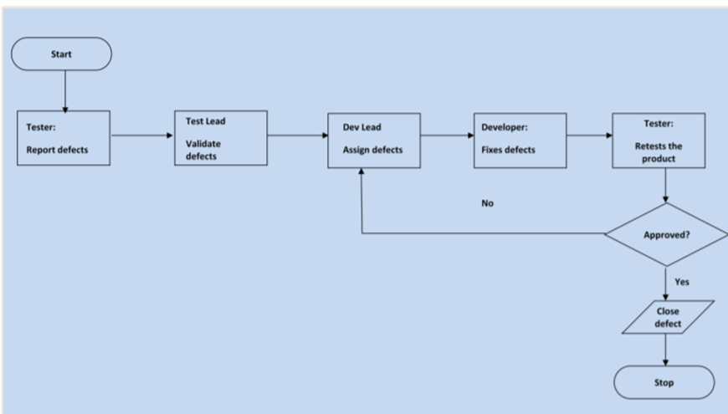

## 6.4. Test management process

### 6.4.1. Testing management tool

Test Cases will be done manually and managed via Excel; Bug reports are written through Word document.

### 6.4.2. Testing process

- Test planning: Right from the beginning of the project, we need to make a test plan.

- Test monitoring and control: Control, monitor and make decisions for test activities. This activity is done throughout from the planning process to the end of the test.

- Test analysis: Analyze requirements, understand requirements.

- Test design: Design Testcases.

- Test implement: Check everything ready for test run.

- Test execution: Executing test.

- Test completion: Report and end the test process.

### 6.4.3. Test risks and mitigation factors

|  |  |  |  |
| --- | --- | --- | --- |
| **Risk** | **Prob** | **Impact** | **Mitigation Plan** |
| SCHEDULE  Testing schedule is tight. If the start of the testing is delayed due to design tasks, the test cannot be extended beyond the UAT scheduled start date. |  |  | The testing team can control the preparation tasks (in advance) and the early communication with involved parties. Some buffer has been added to the schedule for contingencies, although not as much as best practices advise |
| RESOURCES  Not enough resources, resources on boarding too late. | Medium | High | Holidays and vacation have been estimated and built into the schedule; deviations from the estimation could derive in delays in the testing. |
| DEFECTS  Defects are found at a late stage of the cycle or at a late cycle; defects discovered late are most likely be due to unclear specifications and are time consuming to resolve. | Medium | High | Defect management plan is in place to ensure prompt communication and fixing of issues. |
| SCOPE  Scope completely defined | Medium | Medium | Scope is well defined but the changes are in the functionality are not yet finalized or keep on changing |
| Natural disasters | Low | Medium | Teams and responsibilities have been spread to two different geographic areas. In a catastrophic event in one of the areas, there will resources in the other areas needed to continue (although at a slower pace) the testing activities. |
| Non-availability of Independent Test environment and accessibility | Medium | High | Due to non availability of the environment, the schedule gets impacted and will lead to delayed start of Test execution. |
| Delayed Testing due to new Issues | Medium | High | During testing, there is a good chance that some “new” defects may be identified and may become an issue that will take time to resolve. There are defects that can be raised during testing because of unclear document specification. These defects can yield to an issue that will need time to be resolved. If these issues become showstoppers, it will greatly impact on the overall project schedule. If new defects are discovered, the defect management and issue management procedures are in place to immediately provide a resolution |

Table 3. . Test risks and mitigation factors

### 6.4.4. Communications plan and team roster

***Test team***

- Develop test conditions, test cases, expected results, and execution scripts.

- Perform execution and validation.

- Identify, document and prioritize defects according to the guidance provided by the Test lead.

- Re-test after software modifications have been made according to the schedule.

- Prepare testing metrics and provide regular status

***Test Lead***

- Acknowledge the completion of a section within a cycle.

- Give the OK to start next level of testing.

- Facilitate defect communications between testing team and technical/development team.

***Development Team***

- Review testing deliverables (test plan, cases, scripts, expected results, etc.) and provide timely feedback.

- Assist in the validation of results (if requested).

- Support the development and testing processes being used to support the project.

- Certify correct components have been delivered to the test environment at the points specified in the testing schedule.

- Keep project team and leadership informed of potential software delivery date slips based on the current schedule.

- Define processes/tools to facilitate the initial and ongoing migration of components.

- Conduct first line investigation into execution discrepancies and assist test executors in creation of accurate defects.

- Implement fixes to defects according to schedule.

## 6.5. Test environment

Web application for farmers:

- Google Chrome Version 107.0.5304.107 – Desktop screen

Mobile application for merchants:

- Android Version 10 – Vsmart Active 3

Manual/Automation API Testing:

- Postman v10.2.2

# CHAPTER 7. CONCLUSION

## 7.1. Achieved result

* About knowledge and skills:

The course provides the background knowledge in new technologies and framework in software programming and engineering. Especially in new methods for software development.

Students are provided with knowledge about Java, Javascript new frameworks, and TensorFlow machine learning. In addition, there is knowledge of setting environtment, designing, implementing, testing, packaging and deploying a software product. Along with external skills such as communication, teamwork, project management and report writing.

The team learned more about Spring Boot framework, Angular, React library, mastered Java and Javascript languages, and also learned about TensorFlow. We learned about frontend, backend division, how to use API, manage Jackson packages, and use a TensorFlow model in the project.

* About the topic:

The program built by the team has fully ensured the basic required functions for a system of buying and selling agricultural products in website and application.

## 7.2. Advantages

Fully handled ordering process, ensuring fairness for farmers. We let farmers always be the final destination, farmers can only receive new orders when they have enough amount to supply and always take the initiative when receiving orders.

The user interface is guided enthusiastically by the instructors, showing good or bad points continuously, ensuring aesthetics.

Database, applications are uploaded on the internet, users do not need to install third-party applications to be able to use them.

Intergrated a agricultural detection model that can be used to classify those products for further automation process in the project.

The errors have been thoroughly tested by all members who have been learning through the software testing course. Understand the procedures for finding errors and making corrections

## 7.3. Disadvantages

Since our project’s target clients includes famers, therefore it may become too “complicated” and hard to reach to farmers in some specific area. This can be the main problem since in many places that are not too mordern, people are still prefer for the old method since it does not require many steps.

When we want to add new features that might need to have a newer library – this can be leaded to the problems that the older devices are not supported, and it can make the application, which is hard to reach to people in the unmodern areas, becomes more hard.

The mobile app right now only support for some of the main features, however it can be more complicated cases in the real life and requires more feature in the future.

The Machine learning model is used only for classify several agriculturals, some new products can be misclassified.

## 7.4. Future developments

We can add new features to support the dealing prices between the merchants and the farmers to make sure the price will be satisfied between the two.

Right now, there only support for the merchant, in the future we can support for more actors like: the supermarkets or the store owners, …

We will have to research for some specific areas that are not modern to have some plans or solution to make it easy and convenient for people at there places.

We can add more features to support the the transpot methods – which can be really important when ordering.

The Machine learning can be applied to be more useful that can classify more agriculturals, classify each agricultural into its most popular season, and also know which is the popular one to suggest to the users.

**REFERENCES**

1. Amigoscode, Spring Boot and Spring Security with JWT including Access and Refresh Tokens (July 25th 2021)

Retrieved from: *https://www.youtube.com/watch?v=VVn9OG9nfH0&ab_channel=Amigoscode*

2. loda.me, Hướng dẫn Spring Security + JWT (Json Web Token) + Hibernate (May 31st, 2019)

Retrieved from: *https://viblo.asia/p/huong-dan-spring-security-jwt-json-web-token-hibernate-oOVlYGmoK8W*

3. Thomas Hamilton, What is Software Testing? Definition (October 29, 2022)

Retrieved from:

*guru99.com/software-testing-introduction-importance.html*

4. Tran Thi Thanh Tuyen, Các Test Level trong kiểm thử phần mềm (th 8 18, 2019)

Retrieved from:

*https://viblo.asia/p/cac-test-level-trong-kiem-thu-phan-mem-djeZ14AJKWz*

5. Thomas Hamilton, Levels of Testing in Software Testing (November 5, 2022)

Retrieved from:

*https://www.guru99.com/levels-of-testing.html*

6. The nFocus Team, Testing Methodologies – Five Core Components of Testing (June 06, 2022)

Retrieved from:

*https://blog.nfocus.co.uk/testing-methodologies-five-core-components-of-testing*

7. Geeksforgreeks, Software Testing Techniques (01 Mar, 2021)

Retrieved from:

*https://www.geeksforgeeks.org/software-testing-techniques/*

8. Thomas Hamilton, Software Testing Techniques with Test Case Design Examples (November 2, 2022)

Retrieved from:

*https://www.guru99.com/software-testing-techniques.html*

9. Thomas Hamilton, Software Testing Methodologies: Learn QA Models (November 5, 2022)

Retrieved from:

*https://www.guru99.com/testing-methodology.html*

10. baeldung, Spring Data JPA Delete and Relationships (September 5th, 2022) Retrieved from: *https://www.baeldung.com/spring-data-jpa-delete*

11. Michał Pierzchała - Head of Technology at Callstack, React Native Core Contributor Summit 2022

Retrieved from: *https://reactnative.dev/blog*

**WORKFLOW**

|  |  |  |
| --- | --- | --- |
| **ID** | **Student Name** | **Work** |
| 19110151 | Pham Viet Anh | Spring boot, Tensorflow |
| 19110145 | Tran Dang Khoa | React Native |
| 19110100 | Nguyen Le Minh Nhut | Angular |